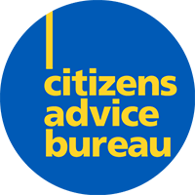

 |  | Caithness Citizens Advice Bureau Annual Report 2024/25
 |  | Scottish Charity Number – SC002849 A company limited by guarantee Registered in Scotland Number 109193 Registered office – 1a Beach Court, Thurso, Caithness, KW14 8AD Registered as a charity by Inland Revenue
Welcome to our Annual Report  Table of Contents  Introduction Key Achievements  Chair Report Chief Officer Report  Our People  Our Funders  Financial Report  Our Advice  Money Advice Report  Welfare Rights Report  Energy Report  Training Report  Client Feedback  How to Get in Touch |  | 

Caithness Citizens Advice Bureau
Introduction
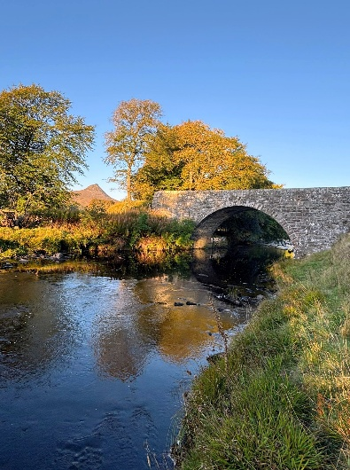
The trustees, who are also directors of the charitable company for company law, are pleased to present their annual report and the financial statements for the year ending 31 March 2025.

The financial statements comply with the Charities and Trustee Investment (Scotland) Act 2005, the Charities Accounts (Scotland) Regulations 2006 (as amended), the Companies Act 2006, the Memorandum and Articles of Association, and Accounting and Reporting by Charities: Statement of Recommended Practice applicable to charities preparing their accounts in accordance with the Financial Reporting Standard applicable in the UK and Republic of Ireland (FRS 102) (effective 1 January 2019).

Key Achievements 2024/25
In 2024/25, Caithness Citizens Advice Bureau (Caithness CAB) continued to offer a valued and supportive advice service to the community:

- We advised 1,753 clients across 16 main advice areas with 8,278 enquiries.

- We secured Client Financial Gains of over £2m for the local community.

- We received excellent feedback from clients, confirming the life-changing services we provide.

- We increased our services to include opening on bank holidays (except for Christmas and New Year).

- We provided home visits to clients who were unable to attend the bureau.

- We put in place a new Food Insecurity service for clients (working in conjunction with Caithness Foodbank).

- We engaged with stakeholders and other third sector organisations through attendance at events and hubs.

- We engaged in new funding opportunities to allow for planning.

- We implemented a business development sub-group (board members and Chief Officer).

- We undertook a staffing restructure to ensure we remain sustainable in offering services to meet client demand.

- We purchased new IT equipment to enhance our service delivery.
Chair Report

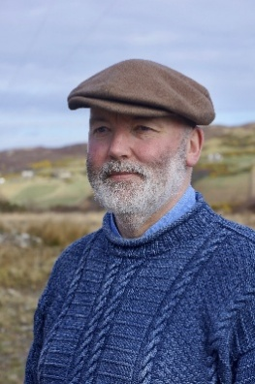
Welcome to the Caithness Citizens Advice Bureau Annual Report for 2024/5.

Caithness CAB is the sum of its parts. The team has achieved more than £2 million in financial gains for clients in 2024/5. This is down to our hard-working, dedicated staff, who provide a free, confidential, non-judgemental, professional, nationally audited local advice service.

The team are here to listen, help and support those challenged daily by the
consequences of debt, benefits advice, housing, energy bills, etc. It is sometimes forgotten that at times this can also be an emotionally draining experience for our staff.

On behalf of my fellow directors, I take this opportunity to thank the team at Caithness CAB for their commitment, hard work and dedication to their community. Without you, there wouldn't be a CAB.

Caithness CAB is your local campaigning and advisory service run by local people for local people.

I would also like to thank the board of directors for their support over the last 12 months.

The last word:
You’re not alone with Caithness CAB.

Michael Simpson - Chair

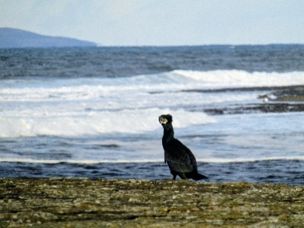

Chief Officer Report

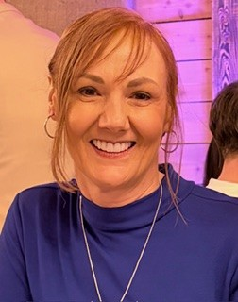
Having now completed my first full year as Chief Officer with Caithness CAB, being
adaptive and responsive to the evolving needs of our community has been at the forefront of all my planning and change. Although 2024/25 has been a very challenging year, we also have many great things to celebrate in our organisation.

Our workforce continues to be our number one asset, and without them, paid staff, and volunteers, we would not be able to deliver the outcomes we have achieved. They work daily in challenging circumstances to make practical changes for our local community, and I once again want to take this opportunity to express my appreciation for their outstanding work and their invaluable commitment to Caithness CAB.

I would also like to acknowledge staff who, during this reporting year, moved on to other employment or retired, as well as volunteers who resigned for personal reasons. We are incredibly grateful for all your hard work and contributions to Caithness CAB.

To grow and be sustainable, the organisation underwent a staffing restructuring towards the end of this reporting period, which was warmly welcomed by paid staff and volunteers. This restructuring included creating two team leader roles and planning for a business sustainability officer role.

Like other third sector organisations, sourcing funding has been challenging due to significant changes in our funding landscape. To be both reactive and proactive, we have had to make some tough decisions to remain sustainable. These changes will continue into the following reporting year, where we will start to see further positive outcomes for both internal and external stakeholders.

The ongoing cost-of-living crisis continues to have a far-reaching effect on our clients. Rising food prices and energy bills have pushed many clients into challenging situations. Our teams are always here to help everyone with free, impartial, and confidential advice, providing a professional and compassionate approach, and being responsive to those in crisis. We have also put in place a new service for clients who are experiencing food insecurity. The new service provides people with food insecurity the opportunity to claim additional income (if eligible) to spend on necessities, which, in turn, should empower them to take control of their financial situation and build a brighter future for themselves and their families.

Towards the end of this reporting year, we also secured 50% of the funding for an outreach project to take our services into our rural communities. In the future, into 2025/26, we are confident we will secure the remaining funding so we can embark on this exciting project and start further engagement within our rural areas.

Our 2025 to 2026 goals include a shift towards a new service approach to make our advice service more sustainable and reduce disparities in access to our services; recruitment of new advisers for our outreach project; a premises overview; recruitment of a business sustainability officer; and phase two of our staffing restructure. Additionally, we will plan in response to community needs, and I look forward to working with the trustee board, our staff, and volunteers to make this happen.

Jane MacIntosh – Chief Officer

Our People – 2024/25

Board of Directors:
- Michael Simpson (Chair)
- Catherine Simpson (Vice Chair)
- Cllr Jan McEwan
- Cllr Willie Mackay
- Sadie Kevill (appointed 5 August 2024)
- Philip Prideaux (appointed 9 December 2025)
- Struan Mackie – (resigned 27 February 2025)
- Bryan Dods – (appointed 27 February 2025)
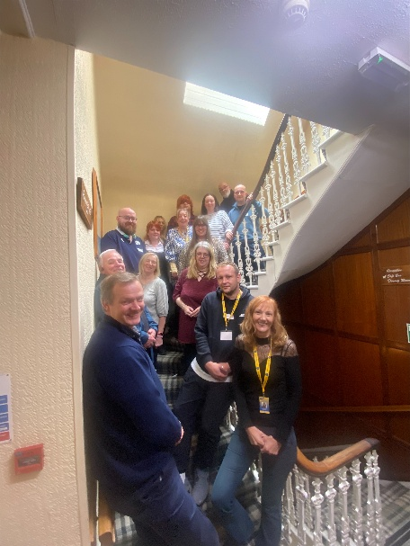
- Cllr Ron Gunn (appointed 7 March 2025)

Volunteers:
- Mara Signori
- Charlotte Murphy (resigned 2024/25)
- Erin MacIntosh (resigned 2024/25)
- Shona Hamsworth (resigned 2024/25)

Paid Staff:
- Jane MacIntosh
- Elaine McGee
- Steven Smith
- Charlotte Mackay
- Fiona Morrison
- Heather Miller
- Maureen Coghill
- Richard MacLeod
- Elaine McIvor
- Sarah-Louise Foster
- Nicolle Robertson
- Kerrie Mackenzie
- Fiona Inrig
- Helen Hawkins (resigned 2024/25)
- Grace Campbell (resigned 2024/25
- Katrina Doull (resigned 2024/25)
- Angela Donaldson (retired during 2024/25)
Our Funders

We are very grateful to our funders, without whom we wouldn’t be able to deliver our service to the community.

The greatest challenge facing Caithness CAB is sustaining the level of service provided to current and future clients year to year.

Meeting the funding gap is always a challenge; however, we remain positive in our outlook and are continually looking for new, longer-term sources of income.

We want to extend our thanks to the following funders during this reporting year:

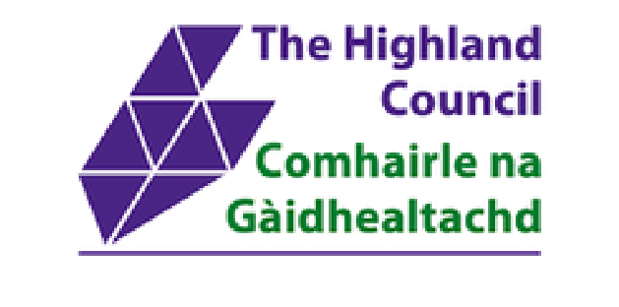
Highland Council – the Highland Council recognises the vital work of Caithness CAB and provides essential funding to cover a wide range of core costs and services within the bureau, including benefits, debt and housing.

CAS Supported Projects – we remain grateful to Citizens Advice Scotland (CAS) and their

business development/project teams for securing funding for specific projects, including
Money Talk Plus, SSEN, Energy, Gambling and Council Tax.

CAS also provides small funding grants for specific in-house projects, for which
We are eternally grateful.


Robertson Trust – funding received from the Robertson Trust has supported the recruitment of a trainer to help train staff and volunteers in-house. All advisers participate in a robust training programme to ensure they meet the standards set by CAS and Gateway, as well as those set by legislation.


Trussell Trust – we secured funding for a two-year project from Trussell Trust (via Caithness Foodbank) to recruit a Food Insecurity Adviser. We work very closely
with Caithness Foodbank on this project.


Foundation Scotland – we are incredibly grateful for their award of £50,000, announced for 2025/26 and 2026/27 as unrestricted funding.

Financial Report

Financial Overview

The annual accounts are available alongside the 2024/25 annual report for perusal.

In summary:

- Income for the reporting period was £305,965.

- Expenditure for the reporting period was £389,625.

- The company generated a deficit in the reporting year 2024/25 of £83,660 (in 2024, we had a deficit of £49,952).

- The company has total reserves at 31 March 2025, of £83,284 (in 2024 we had reserves of £166,944).

The main risks and uncertainties facing Caithness CAB are falling grant income and significant maintenance and operating costs associated with two operational sites.

Our Advice

In total, Caithness CAB gave advice 8,278 times over the reporting year, supporting 1,753 clients with Client Financial Gain of £2,058.5K.



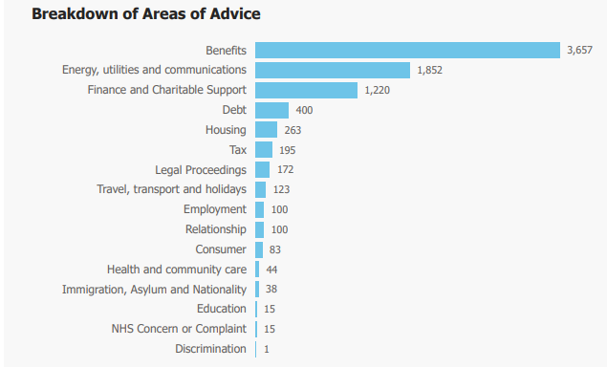

The main ways people contacted Caithness CAB were:
Telephone 70%
Personal 17%
Email 11%
Other 2%

Money Advice Report

Over the last year, we remained busy with debt cases despite being short-staffed in this area for a period, where clients were signposted to another advice agency in the interim.

Despite this, we are delighted to have assisted a total of 33 clients from the Caithness area during 2024/25, with a combined debt of £371,082.22.

The leading debt solutions currently for clients are Bankruptcy or the Debt Arrangement Scheme (it is rare nowadays for clients to enter a voluntary repayment plan due to the ever-increasing cost of living). This is because most of our clients have little or no disposable income to pay their creditors, so they feel bankruptcy is their only option. Once a client is granted bankruptcy, their debts are written off, and they can start afresh without the worry of heavy debt.

For clients with sufficient disposable income to pay their debts, they usually opt for the Debt Arrangement Scheme (DAS), which allows them to make a single monthly payment that covers all their debts and continues until all their debts are paid.

From the date a client applies for a DAS, all interest and charges are frozen, and the client's creditors pay the costs of setting up and administering the DAS. A DAS is ideal for homeowners and clients who wish to keep their assets. Payments to their DAS must be kept up to date, as their assets are protected, unlike in bankruptcy, where they could lose some of their assets.

When a client comes to the bureau for assistance with their debts, while they are deciding which option to choose, they can apply for a Statutory Moratorium, which gives them 6 months to determine and set up whichever option they ultimately choose.

I look forward to continuing to assist as many people as possible over the coming year with their debts and to help them find the ideal solution for their circumstances.

Heather Miller - Specialist Adviser

Welfare Rights Report

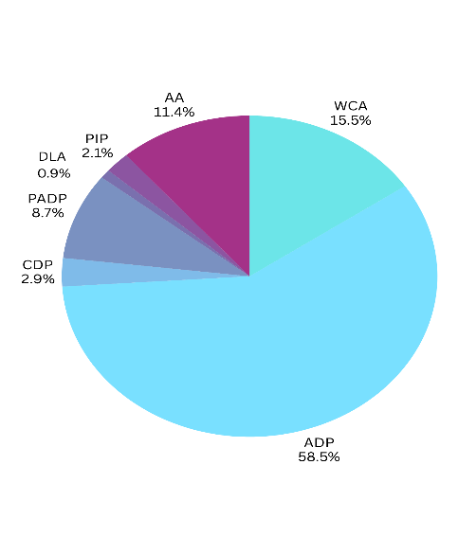
Throughout the reporting period, time was spent organising and completing clients’ Adult Disability Payment (ADP), Child Disability Payment (CDP), Pension Age Disability Payment (PADP), Attendance Allowance (AA), and Disability Living Allowance (DLA) claim forms from initial application to review, renewals, reconsiderations/re-determinations and appeals. In addition, a substantial amount of time was spent on completing UC50's limited-capability-for-work questionnaires and on subsequent mandatory reconsiderations and appeals.

The Department for Work and Pensions (DWP) continues to conduct medical assessments in the local area by telephone. Delays in clients receiving medical assessments remained at 12 weeks, with a further 4 to 6 weeks before the DWP decides on the claim. In contrast, SSS continues to rely on medical evidence supplied by the claimant or reports sought directly from medical professionals.

The lack of in-person medical assessments continues to present a particular disadvantage to clients with physical disabilities. Disadvantages to clients with mental health issues also remain, as the lack of a face-to-face interview makes it more difficult for a supporting third party to participate.

PADP was developed by SSS as a replacement for Attendance Allowance and was introduced through a phased approach, starting with a pilot launch in selected local authorities in October 2024, including the Highland region. This has been the most significant change in welfare benefits during the reporting period. Transfers from AA to PADP have been automated for eligible recipients in Scotland, with the process phased in from early 2025.

Social Security Scotland’s “Light Touch Review” scheme, when transferring a claimant from PIP to ADP, remains highly beneficial and time-saving for both staff and clients.

In the future, a close liaison with government departments such as DWP and SSS, as well as the local Jobcentre Plus, remains a priority, and we hope to continue developing this.

We want to take this opportunity to thank all staff and volunteer advisers for their invaluable help and enthusiasm throughout the year.

Steven Smith – Team Leader and Specialist Adviser
Fiona Morrison – Specialist Adviser


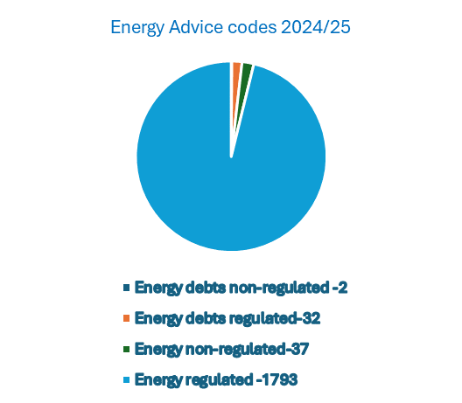

Energy Report
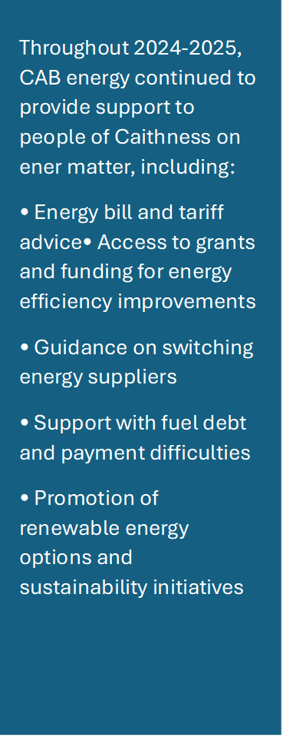

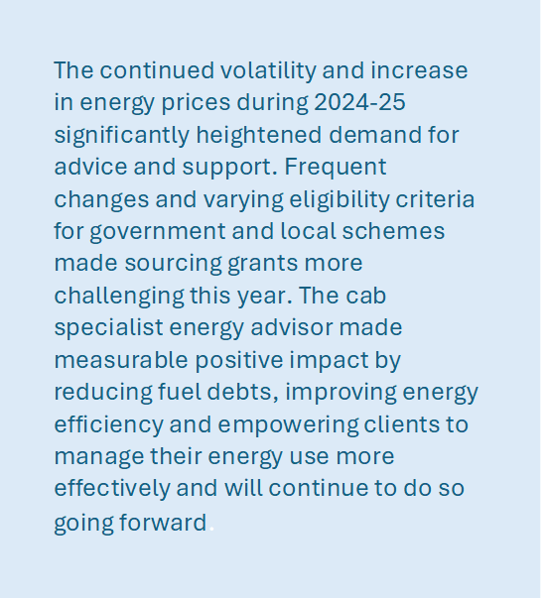

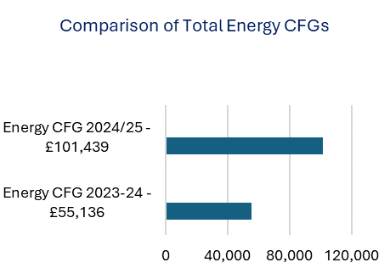
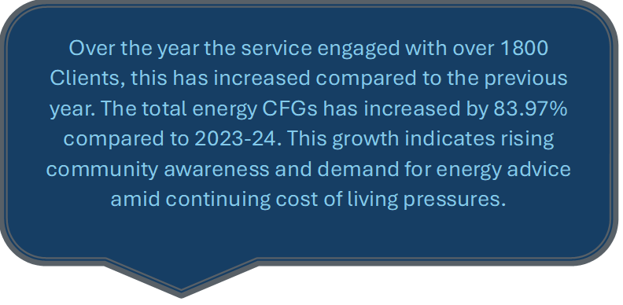
Charlotte Mackay – Specialist Adviser
Feedback


“Do you know what you mean to me
and how much I appreciate

All your help!”

“CAB has made such a difference to our family and daily lives”

“The advisers are amazing.
They always take the time to explain
things I don’t understand”

“The advisers are amazing”

“From the bottom of our hearts, we can’t
thank you enough for everything that you
did to help and support us with this”

How to Get in Touch
Giving you the power to deal with your problems
Caithness Citizens Advice Bureau is here to help.


Email us THU-bureau@caithnesscab.casonline.org.uk


Advice in person


Call us 01847 894243

General Advice / Drop-in
10 am - 2 pm (Monday to Friday)

Specialist Appointments
9 am - 4 pm (Monday to Friday)

Online support tools are available at:
Citizensadvice.org.uk
Caithness.cab.cas.org.uk

