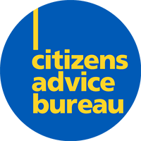
January 2026
Vol 1

 |  | Caithness CAB Newsletter
 |  | Free, confidential, impartial advice for everyone
INSIDE  __  About Caithness Citizens Advice Bureau  CAB provides advice on a range of matters, supporting individuals and families within the community.  __  How can we help  Our team offer practical advice, advocacy and support tailored to individual circumstances.  __  Worried about this Winter campaign  A Citizens Advice campaign to highlight the issues surrounding high energy and heating costs this winter. |  |   Charity Number – Sc002849

Caithness Citizens Advice Bureau
  What is Citizens Advice?  Citizens Advice is a national charity and network of local bureaux that provides practical advice, information and support to people in the community. This information allows individuals to understand their rights, explore their options, and make informed decisions.  At Caithness Citizens Advice Bureau, our advisers work directly with people in the community, offering guidance and support on issues that can feel overwhelming. We aim to help people feel heard, supported, and able to make informed decisions and improve their circumstances.  We work alongside other local services and organisations to ensure people receive the right support at the right time. Where appropriate, we refer and signpost clients to specialist services, helping them access wider support within the community. |  |  | How we support people in Caithness  Caithness Citizens Advice Bureau is here to offer free, impartial and confidential advice to citizens of Caithness and North Sutherland west to Bettyhill and District. We deliver support and guidance across a range of topics, giving people the information they need to handle any situation and improve their lives.  Areas of advice  - Debt and money  - Benefits  - Energy  - Employment  - Housing  - Family and relationships  - Law and courts  - Immigration  - Health  - Food insecurity
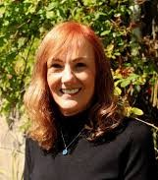 | We are starting 2026 amid the ongoing cost-of-living crisis, which continues to affect our clients, with rising food prices, unaffordable energy bills, and the challenges winter can bring. We want anyone experiencing difficulties to know that we are here to help you feel supported and in control of challenging situations. Caithness CAB is always here to help you take positive steps forward, with our free, impartial, and confidential support and advice services, available to everyone.’ - Jane MacIntosh, Chief Officer.

Caithness Citizens Advice Bureau
Our impact on the community
Each year, Caithness Citizens Advice Bureau supports people across the community with a wide range of concerns and challenges. People contact us at different points in their lives, often when things feel uncertain or overwhelming. Through advice and guidance, we help people understand their situation, explore their options, and move forward.
While people contact us about a variety of matters, some issues affect more people than others. Understanding these trends helps us respond to the needs of the local community and provide targeted support where it is most needed.
Over the past year, one of the most common reasons people contacted Caithness Citizens Advice was money, debt, and benefit concerns. Our team supported the local community in resolving issues and achieving practical outcomes.
IN 2024/25:
- 1753 clients
- £2,058,500 in client financial gain



“The advisors are amazing. They always take the time to explain things I don’t understand.”
“CAB has made such a difference to our family and daily lives, we really appreciate it.”

Current Campaigns
Worried this Winter?
You’re not alone.
This winter, rising energy costs continue to place pressure on households across Scotland, with 1 in 3 people stating energy bills are their biggest financial concern. Energy bills remain unaffordable for thousands of people, forcing many to cut back on expenses or sit in cold, dark homes to get by.
More than a quarter (28%) of people in Scotland say their energy bill worries have impacted their mental health. The Worried this Winter Campaign, introduced by Citizens Advice Scotland, highlights the issues currently prevalent in Scotland and reminds everyone that we are here to help.

A local case study

This winter, our advisors supported many people worried about energy costs. The following local case reflects the issues highlighted by the Worried this Winter campaign. An individual contacted our service after discovering an unexpected debt on their pre-payment energy meter, despite regularly topping up. The situation caused significant financial strain and worry, as the person was unsure how the debt had arisen.
Our advisor contacted the energy supplier, challenged the charges and ensured the case was escalated. Incorrect repayment charges were removed, and the account was reviewed to prevent further unfair costs.
This support reduced immediate financial pressure and reassured the client during a stressful time, demonstrating the real difference early advice can make.

If you’re worried about energy costs, you don’t have to face it alone- we’re here to help.

Caithness Citizens Advice Bureau
IN 2025:
Caithness CAB was contacted 8,278 times, supporting 1,753 clients, and achieving a financial gain of over £2M.

How people contact us
If you feel you require advice, or would like to discuss a concern, Caithness Citizens Advice Bureau offers several ways to get in touch.
People contact us for a variety of circumstances, and in every case our advisors aim to support the community and ensure the best possible outcome.
Last year, people contacted us using various methods.

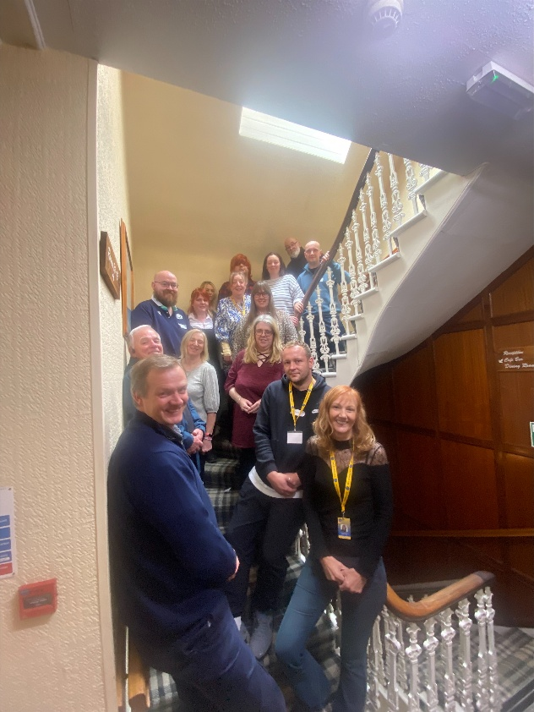
The main ways people accessed our services were:

70%
Telephone



18%
Face-to-face

12%
Email/Letter

How to get in touch
Giving you the power to deal with your problems.
Caithness Citizens Advice Bureau is here to help.

Call us 01847 894243
Email us THU-bureau@caithnesscab.casonline.org.uk

Advice in person

General Advice / Drop-in
10 am - 2 pm (Monday to Friday)
Specialist Appointments
9 am - 4 pm (Monday to Friday)

Online support tools are available at:
Caithness.cab.cas.org.uk
Citizensadvice.org.uk

